

Live Better Again

Iteration 1 Report

Version 1.1

**Team 106**

Team Members:

Allison Tang

Joshua Brown

Trista Li

Frank Nacional

Bryan Sim

Contents

**Introduction 2**

**Delivery cycle overview** **3**

Overall delivery cycle plan 3

Updated functional decomposition diagram 4

Current delivery cycle plan 5

**Review and feedback form 6**

**User access and instructions 8**

**Appendix 9**

Introduction

The purpose of this report is to give all relevant stakeholders an in depth look at what has been achieved for iteration 1. The document outlines the following completed functions for administrator use:

* Patient registration
* Account registration and management

This documentation includes an overview of the delivery cycle plan, function descriptions as well as review and feedback forms.

Delivery Cycle Overview

Overall Delivery Cycle Plan (revised)

|  |  |  |  |
| --- | --- | --- | --- |
| **Iteration** | **Functions** | **Priority** | **Date of Iteration End** |
| Iteration 1 | Account registration (Functions 1.1-1.3) | High | 20th September 2017 |
| Patient registration form (Functions 2.1-2.2, 2.7) | High |
| Electronic consent forms (Function 2.3) | High |
| Iteration 2 | Medicare forms and PDF files (Functions 2.4-2.6) | High | 14th October 2017 |
| Clinic reports (Function 6.1) | Medium |
| CPAP tracking (Functions 3.1-3.4) | Medium |
| Technician appointments and calendars (Functions 4.1-4.2) | Medium |
| Iteration 3 | Invoicing (Functions 7.1-7.3) | Medium | 27th November 2017 (TBC) |
| Recording of patient treatments and notes (Function 2.8) | Medium |
| CPAP sales inventory tracking (Function 7.4) | Low |
| Iteration 4 | Website upgrade | Low | 7th December 2017 (TBC) |

Updated functional Decomposition Diagram (For Iteration 1)

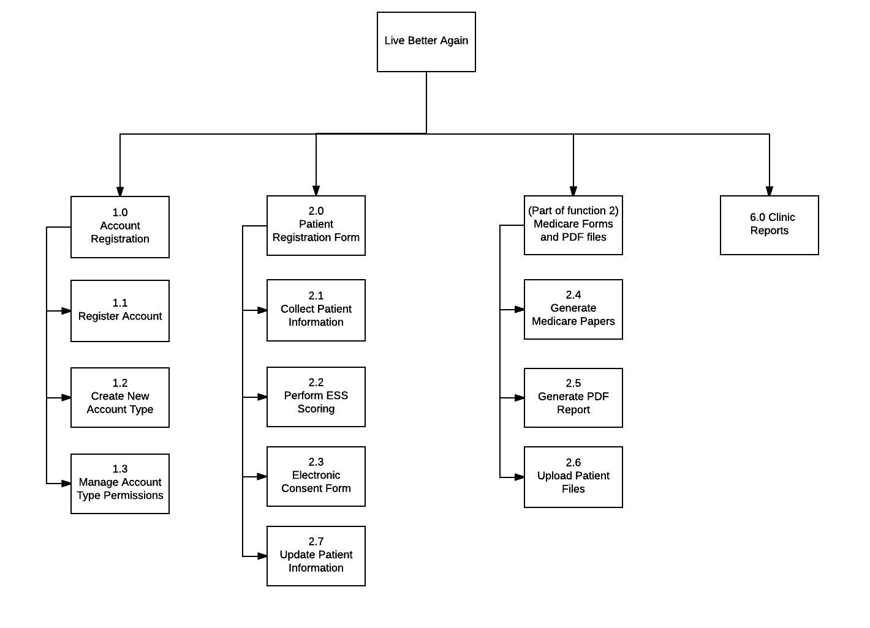

Current Delivery Cycle Plan

|  |  |  |  |
| --- | --- | --- | --- |
| **No.** | **Function name** | **Description** | **Status** |
| 1.1 | Register account | - Administrator is able to create an account for any account type (eg. sleep technicians, administrators | Completed |
| 1.2 | Create new account type | - Administrator is able to create and remove types of accounts eg.for GPs and patients | Completed |
| 2.1 | Collect patient information | - Technician is able to record patient’s personal details and medical information on forms | Completed |
| 2.2 | Perform Ess Scoring | - Technician is able to complete an ESS form and receive a patient’s ESS score | To be completed in Iteration 2 |
| 2.7 | Update patient information | - Technician or administrator is able to edit patient’s information  - Administrator is able to disable and hide old or inactive patients | Completed |
| 2.3 | Electronic consent form | - Technician is able to present an electronic consent form to a patient  - Patient is able to digitally sign the electronic consent form using a mouse | Completed |
| (Part of 2.0) | Medicare form and PDF files | - Technician is able to prepare a Medicare form using the patient’s information and signature | To be completed in Iteration 2 |
| 2.4 | Generate medicare papers | - Technician is able to export a Medicare form in PDF format | Not completed |
| 2.5 | Generate PDF report | - Technician is able to generate the business reports in PDF format | Not completed |
| 2.6 | Upload patient files | - Technician is able to upload patient’s files (eg. referrals) to the system | To be completed in Iteration 2 |

Review and Feedback Form

|  |  |  |  |  |  |
| --- | --- | --- | --- | --- | --- |
| **Delivery Cycle 1** | | | | | |
| Function | | User Story | Acceptance Criteria | Acceptance status:  **U(**Unconditional)  **C**(Conditional)  **R**(Rejected) | Feedback |
| *1.0* | Account Registration | As an administrator, I want to add/remove accounts of new receptionist, technician physician and GP which includes personal details to the system as well as edit permissions to users so that I know how many staff do we currently have in each clinic and have easy access to each accounts. | - Permission changes can only be made by an admin user  - New account types can be created in the future  - Registration is not available to the public |  |  |
| **Manage account type permissions comments:** An administrator is able to edit the permissions for different types of roles and create new accounts under different user roles | | | |  |  |
| *2.0* | Register new patients | As an technician, I want to be able to register a new patient, collect patient information and perform ESS scoring so that I can view my patient’s data at any time and reduce the number of forms to complete. | - Patient data should be collected once and automatically populate other forms  - Data should be stored securely and be protected from unauthorised access |  |  |
| **Register new patients comments:** A new patient can now be registered by a technician, using a multi-stage tabbed form. | | | |  |  |
| *2.3* | *Electronic consent form* | As an administrator, I want to be able to collect signatures digitally, so that I can use a single form to produce consent papers and Medicare reports | - Signature can be collected without additional hardware  - Signature can be stored and reused for Medicare forms |  |  |
| **Electronic consent form comments:** The consent form when registering a new patient can now be input by using a digital input and signing it while being secure (not able to have the signature saved as an image) | | | |  |  |
| **System general comments:** System overall is working as its function states so but bugs are to be ironed out as constraints are not completely placed in order | | | |  |  |
| **Additional comments from Live Better Again:** | | | | | |
| **Delivery Cycle 1 reviewed and approved subject to implementation of documented changes:**  **Client Signature:**      **Date:** | | | | | |

User Access and Instruction

The delivery cycle software can be accessed via the link below:

[http://ie.infotech.monash.edu.au/team106/build1-1](http://ie.infotech.monash.edu.au/team106/build1-1/)

A sample administrator account can be accessed with the follow details::

**Username:** admin

**Password:** admin

A sample technician user can be accessed with the following details:

**Username:** tech

**Password:** tech

The user manual can be accessed via the link below:

<https://docs.google.com/document/d/1vrionRRF9xD1jkTJlXxwrX07-P8Y5x1XjqRu_7y18cU/edit#>

Appendix

*Changes in priority have not changed since the last system overview report and there have been no changes made in terms of functionality or any modifications that needs to be made which will impact this iteration from the initial system overview. (The priorities of each function in this iteration can be found in the overall delivery cycle plan matrix).

Client interaction:

<https://drive.google.com/drive/u/1/folders/0B03Isl3rRcyRYmRpSTFKdFZ6bEk>